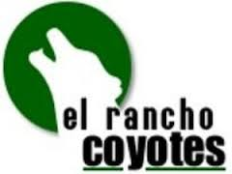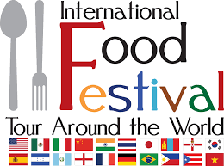

PARENTS- WE NEED YOUR HELP!

What is the International Food Festival? It’s a day for students to taste cuisine from all over the world & celebrate their cultural backgrounds. This is a PTSA sponsored event that helps the students learn a little bit more about other countries. This year the festival will take place on WED., FEB. 8TH in the school cafeteria.

How can you help? We need donations of ethnic food dishes, and help serving the .food throughout the minimum day. (7:00am-12:30pm) This is a great way for you to complete your service hours AND if you donate a food item your student will receive EXTRA CREDIT from their P.E. teacher. This year students will also be allowed to wear clothing from their perspective cultures but ONLY DURING THEIR P.E. CLASS.

If you can help with either (or both) please fill out the bottom portion of this sheet & return it to the office BY FRI., FEB. 3rd, or you can email it to the Int’l Food Chairpersons:
Kathy Watson donandkathy1@sbcglobal.net &
Kelley Sparacino kelleys@canyonhs.foundation
----------------------------------------------------------------------------------------------------

CONFIRMATION SHEET- please cut here

___ My child will bring a dish in for ERCS’s International Food Festival on Feb. 8tH.

STUDENT NAME: __________________________________________________

P.E. TEACHER NAME:__________________________________________

NAME OF FOOD: _________________________ COUNTRY:________________

TIME FODD WILL BE DROPPED OFF: (7-8am is preferred) __________________

I will donate _____cases of water bottles. (sm ½ size bottles preferred)
One case= 1 service hr

I am available to volunteer during the event between the hours of_______________.

PARENT NAME:____________________ EMAIL:________________________

PLEASE RETURN THIS FORM TO THE OFFICE NO LATER THAN FEB. 3RD

